<https://brnrd.me/posts/social-sentiment-sentiment-analysis>

The subjectivity is a float within the range [0.0, 1.0] where 0.0 is very objective and 1.0 is very subjective.

Sub 0 to 1 => 0.5 or over means biased

Pol -1 to 1 => ....

It's helpful to make a distinction between rational and emotional evaluations:

\* Rational evaluation: evaluations from rational reasoning and tangible beliefs (e.g. "The reports from this tool are very useful").

\* Emotional evaluation: evaluations from non-tangible and emotional impulses (e.g. "These reports are the best ever!").

After making this distinction, we could build a sentiment scoring system, taking into consideration the following sentiment ratings:

\* (+2) emotional positive

\* (+1) rational positive

\* (0) neutral

\* (-1) rational negative

\* (-2) emotional negative

==============================================================

<https://www.researchgate.net/figure/Triangle-representation-with-polarity-and-subjectivity-axes_fig2_264557244>

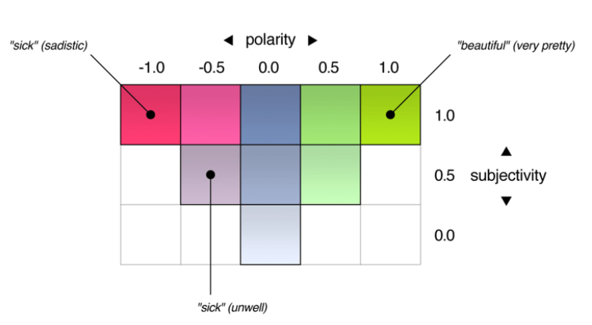

==============================================================

According to the team, the system only needs 150 articles to determine whether a new source can be trusted reliably

<https://www.google.co.uk/amp/s/venturebeat.com/2018/10/03/mit-csails-ai-can-detect-fake-news-and-political-bias/amp/>

==============================================================

<https://towardsdatascience.com/machine-learning-versus-the-news-3b5b479d8e6a>

<https://towardsdatascience.com/ranking-news-bias-in-python-e9bb5d1ba93f>

<https://towardsdatascience.com/my-absolute-go-to-for-sentiment-analysis-textblob-3ac3a11d524>



